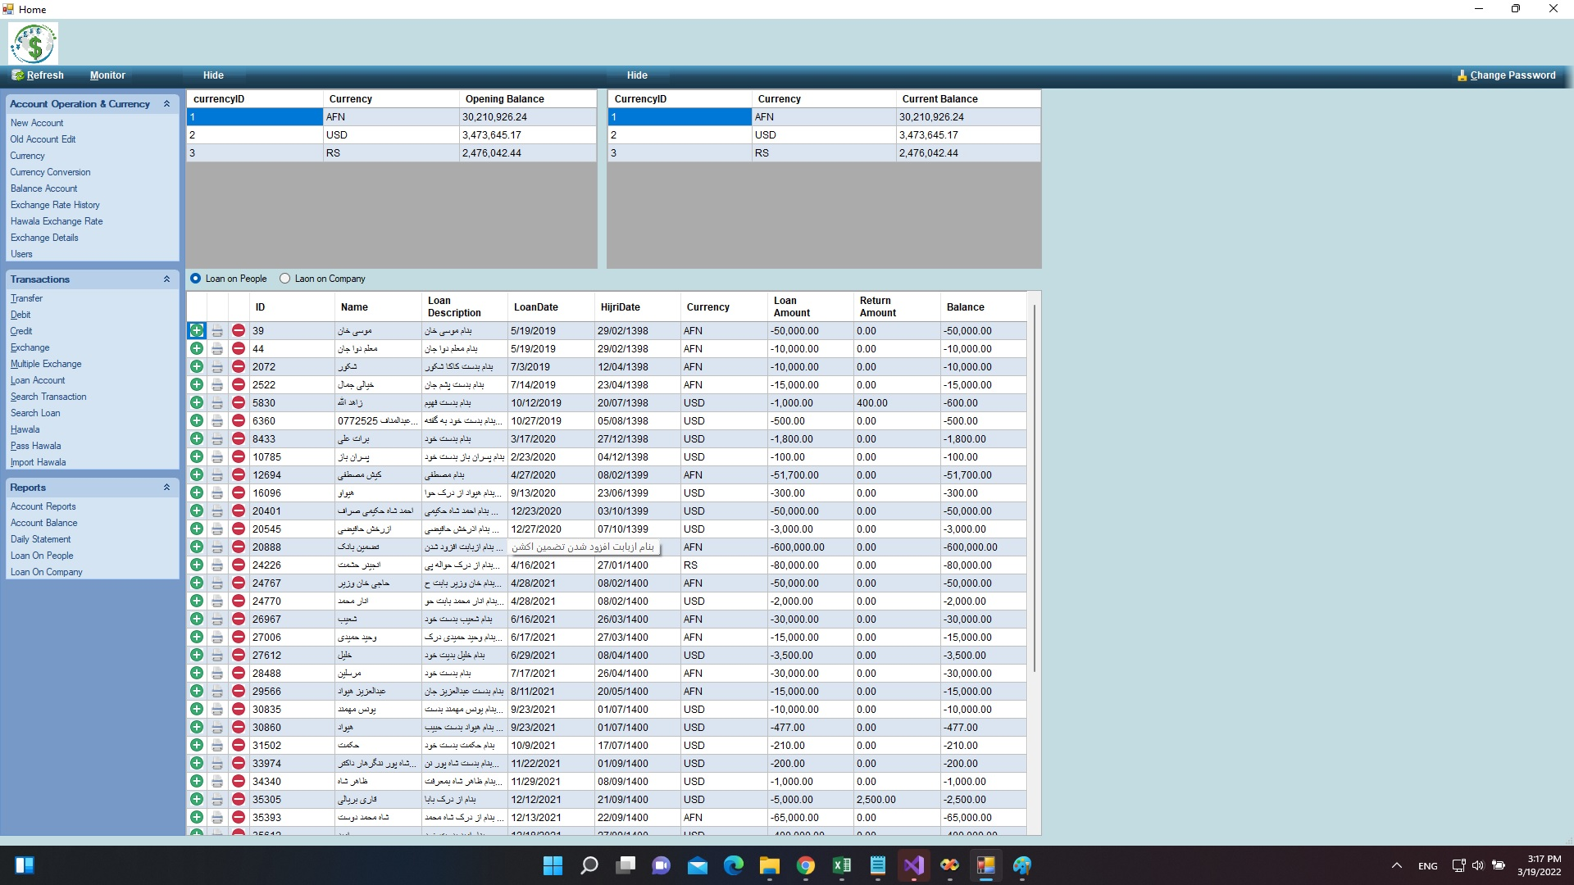

Main Screen or Home screen. This is the first screen.

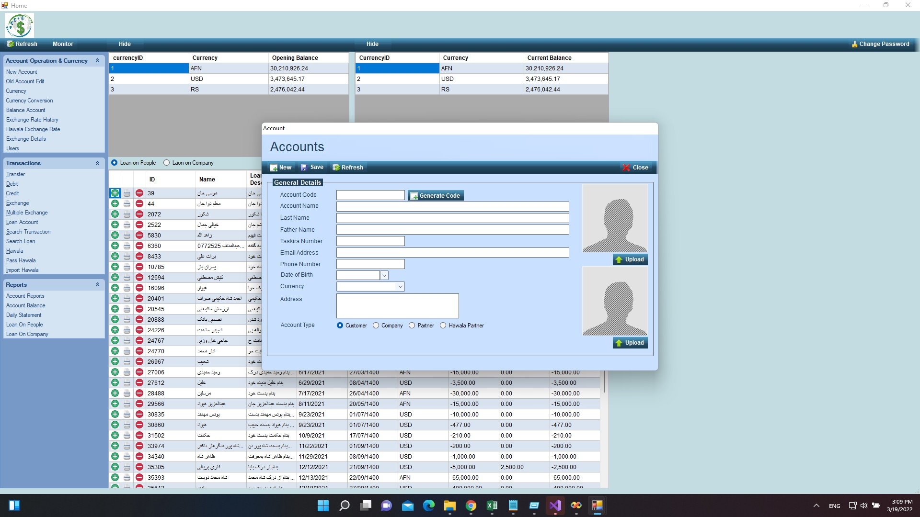

New Account Screen. This screen is used to Open New Account for Customer.

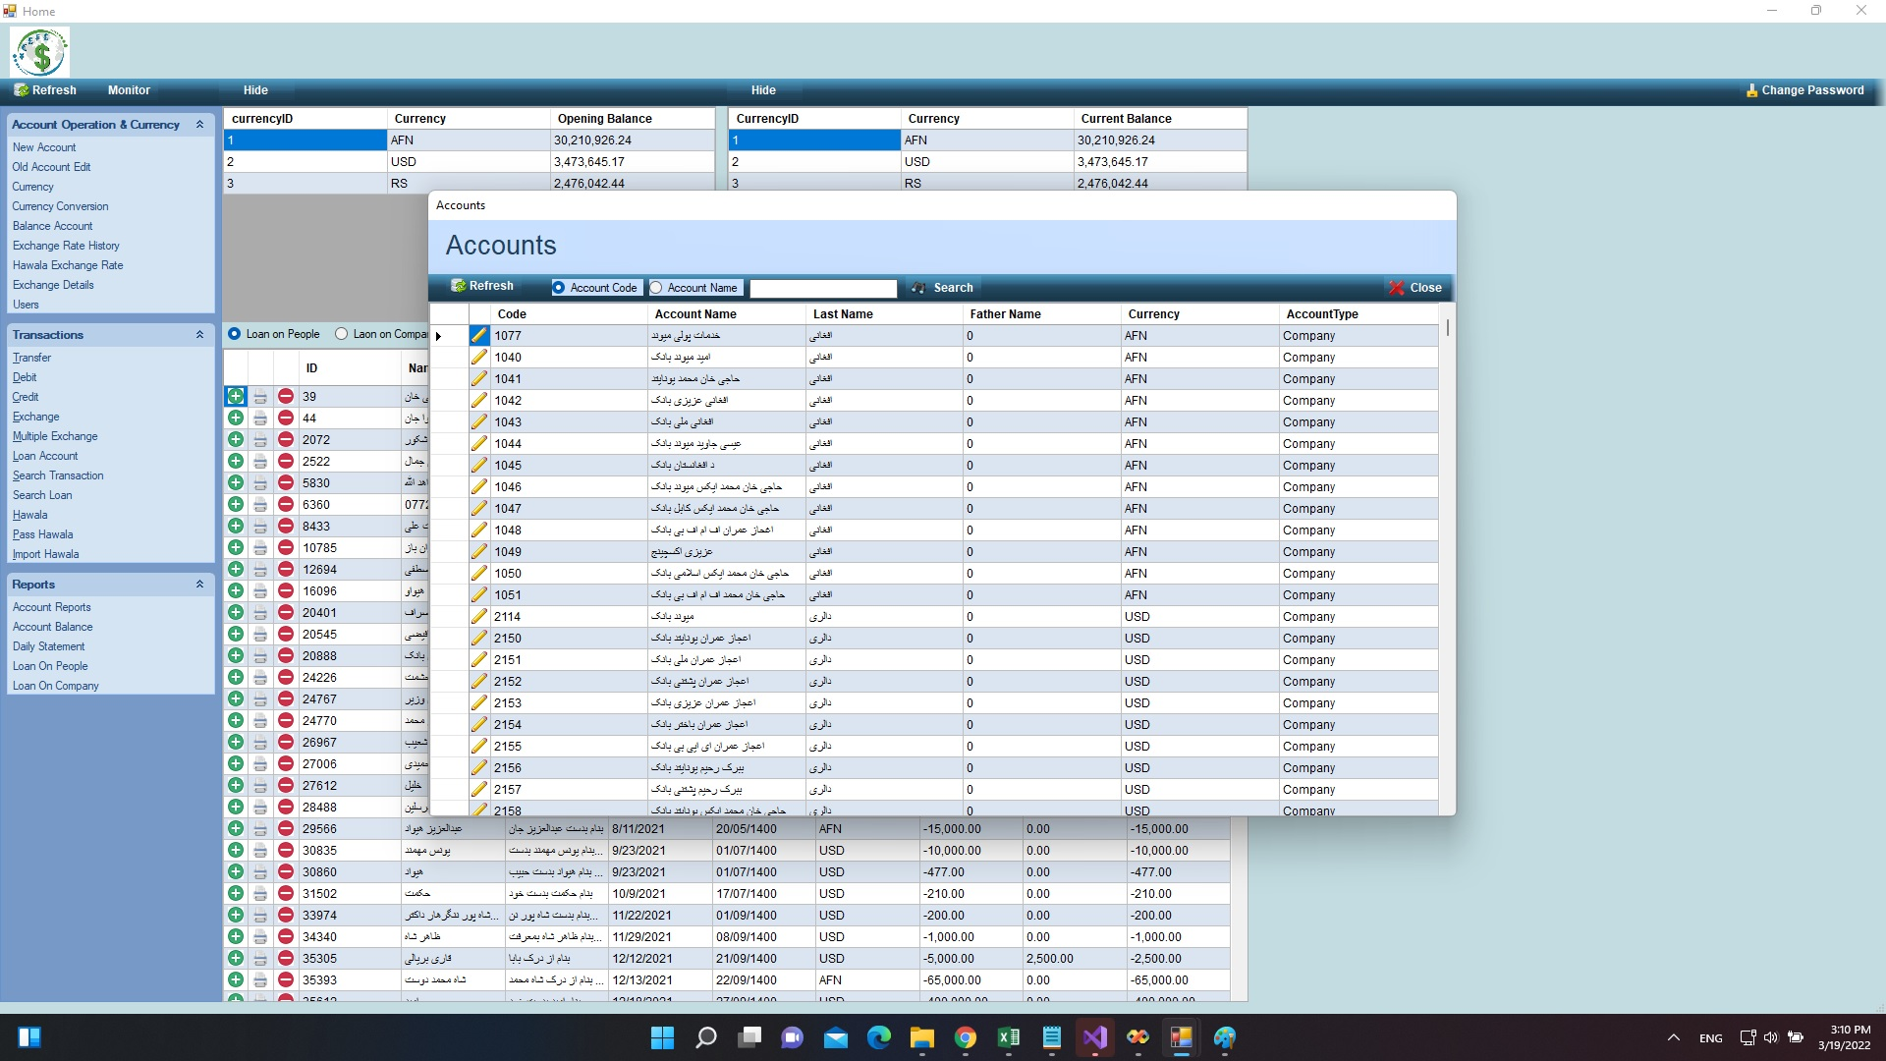

This screen shows list of opened Account.

* 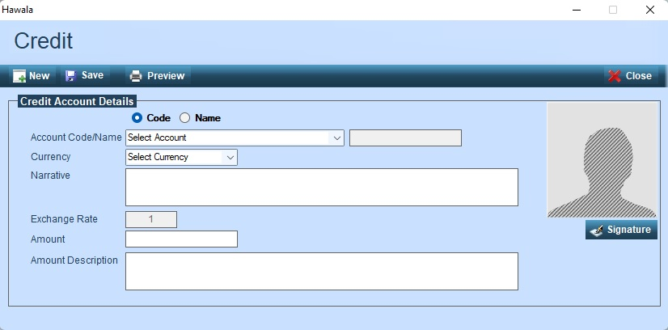

This screen credit the selected account with entered amount.

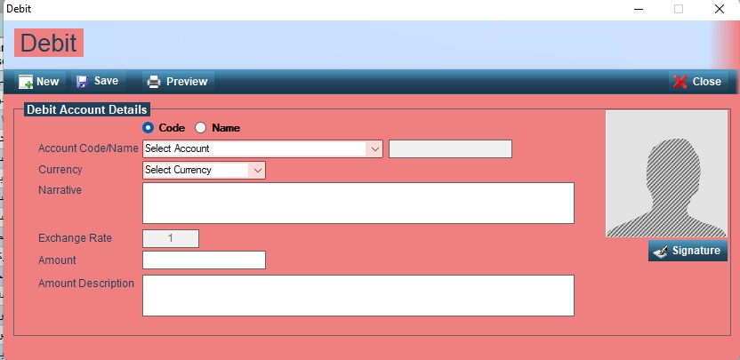

This screen debit the selected account with entered amount.

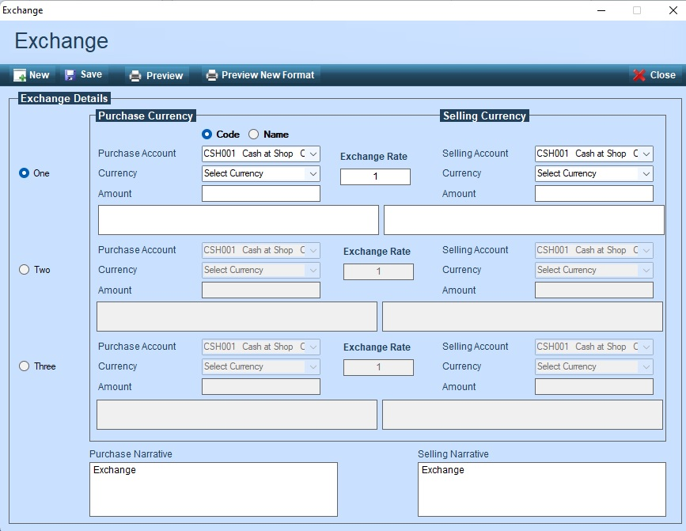

This screen exchange one currency into another. For example AFN to USD or USD to AFN using entered exchange rate.

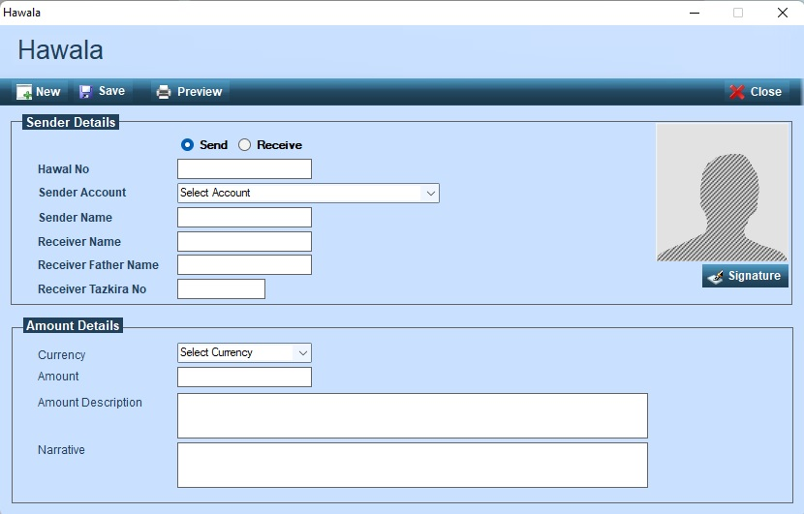

This screen save the send Hawala. Money transfer from one place to another, but we will open accounts for hawala partner.

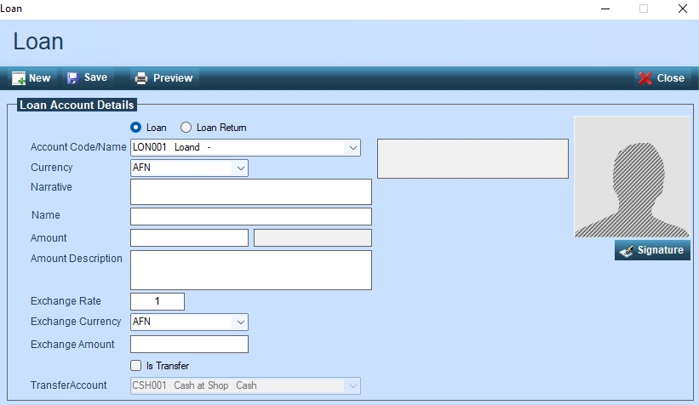

This screen save the given loan and received loan details.